I Am Not a Taskmaster & Is She Preaching Poverty?
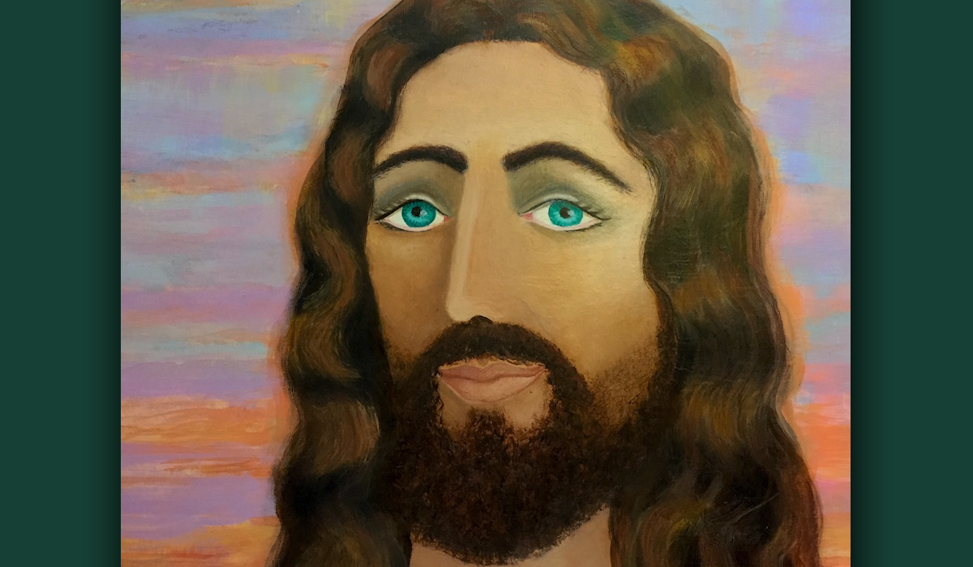
October 3, 2016

The Treasure of Jesus' companionship be with you, precious Friends.

Well, Heartdwellers, I know the last message left some people with a few questions. I didn’t get all the specifics, but it seems that someone thought I was preaching poverty.

In order to understand the context in which the Lord has asked me to be happy with what I have and not look for the newest or latest, you have to understand it is my life calling to serve you. How can I serve you well if my mind is on acquisition and not Jesus? You know how the news can be addictive, and we all know how easy it is to spend hours surfing on the net and come back to your senses asking yourself, “Where did all that time go?” That’s one reason why He doesn’t want me doing that.

If you go back to my original teaching on The Love of Money, in the Wounded Waters series, you will see very clearly the Scriptural basis the Lord is leading me by. My whole life is serving Him and helping the poor. I can’t serve two masters, and that black panther is something I’ve been trying to kill since I knew about it, probably a good 25 years. And it would seem that most of the time it IS dead. But if you remember my original dream, I would overcome it and it would go underwater, and I would think, "Whew, wow! It's dead." Then it would pop back up again when I didn’t expect it and go for my throat.

That was an allegorical dream representing a deadly spirit of Avarice.

I grew up wanting a lot of things which I couldn’t have, because my mother wasn't real wealthy. I went to school with wealthy kids, and loved to shop. But my whole value system was worldly. Then I fell in love with the Lord and I realized I couldn’t serve two masters. Serving myself with nice things and the all-consuming passion for this or that, really crippled my walk.

One year, the Lord broke that stronghold and I was the freest I’ve ever been in my life. I know what that feels like and it is SO wonderful - not to have anything to deal with, other than God.

When we are in the world we need certain things to keep up our lifestyle. When we leave the world to serve full time as missionaries, we leave those things behind. In a sense I am a missionary in my own country…although I do have more than someone who serves overseas. And these things ARE distracting. The ease with which you can go shopping IS ALSO distracting, and I am on board with the Lord about making do. When I really need something, He always supplies for it.

So, please don’t over-react to the message. He is asking ME to make a choice, because I cannot serve myself and you at the same time. I absolutely am much happier when I keep my lifestyle simple. You have to make your own choices and let the Lord guide you as to what you really need. It has nothing to do with poverty and everything to do with faithfulness with His resources and time.

So, I hope this clears the air a bit. I was NOT preaching poverty!

Well, talk about neat confirmations. I had to go on the Internet to look something up real quick, and I got a rhema that says:
"Let us keep going towards the same goal, but by our own path, united in our obedience to God, who manifests His will so differently to each of us."

Wow, what a confirmation, huh?

So, each of us has their own obedience to God and their own path. And I'm not suggesting that you should follow mine, I'm only sharing with you how He's been leading me. And that's basically, as a missionary.

And I had one other announcement that I wanted to make. There was a young lady that wanted to build a room onto her house for her and her daughter, and we have tried and tried and tried to find her. If you happen to be that young lady, would you please leave a comment for Carol? Thank you.

Moving on, yesterday I was the one over-reacting. After a correction like I had, I was over-correcting, even though Saturday is the day when we straighten the house and put groceries away. I was trying to do that and pray as I normally do for several hours. You know all the distractions and interruptions that happen. We had someone helping us, as well. So, my attention was constantly divided…be faithful with a communion service, make sure everything gets done. Did that get put away in the right place? Did the floors get clean? And I was a casualty! I couldn’t do either thing well.

I think the Lord watched this and couldn’t wait to get my attention because He said,
"Clare! I need to talk to you.”

So, I dropped everything and went to a back room with my computer where I could hear Him more clearly.

He began, "There is no need for you to be harried. There is a time for everything. You need to clean the house; that is legitimate. I am not standing over you like a taskmaster cracking a whip, STAND! KNEEL! GO BACK TO COMMUNION! WITHDRAW FROM THE ACTIVITY!

"My Bride, there is a time for everything and today is the day you do housework. Stop being scrupulous! It’s embarrassing to Me, as though I was cruel and demanding. I am not. I understand this is the house’s turn. I’ve made adjustments for that.

"I just want you to be coming to Me first thing every morning, because you have been pulled away numerous times and kept Me waiting. For what? A floor? Dirty dishes? Nothing a Sovereign should have to wait for to see His Bride first thing in the morning and receive her love and affection.
"Not under threat of punishment, but because she loves Me. What I have said to you about putting all the work last was also to spare you the push, the rush, the disorder of going to the world rather than Me, first thing. You have done valiantly to pull away.

"But now I want to moderate things. I know you were saving Me for last so you wouldn’t be pressured by any that needed to be done. Although the concept seems right, it isn’t practical. Have you noticed the things to do, the list, gets longer and longer. Guess who’s behind that one?

"That is why, I want you coming to Me first, My Love. What if I want to spend the whole day with you? Are you available? You see, I can make that choice first thing in the morning when you are fresh and not harried with to-do lists and worldly agendas.

"I want our time to be intimate and sweet, not under threat of punishment. Satan is trying to exaggerate and spill over into unreasonable demands, to sour our relationship. All of you, My Brides, are very sensitive to pleasing Me. So, you are also prone to scrupulous spirits, demons who constantly make you question every single thing you do. That is no way to have a relationship with Me.

"My Yoke is easy, My burden light. Don’t let the enemy convince you otherwise. They will take anything I say and blow it up way out of context to cause you false guilt. What I am looking for is VERY simple. Come to Me, spend time with Me, pray to Me and listen for My words of life and love. And do it FIRST thing in your day.

"I know you need healing. It was a hard shot. But as you have been mulling it over you realized that this was not just for one item, but a habit, springing from self-will and not submitting to Me. THIS is what We are looking for. And you know that most of the time the answer will be ‘no’ because We don’t want you living as the world lives with an eye to what’s new. Besides, it's important for you to help the poor around you.

"What’s old and usable is always best. That way, you are not entangled in endless revisions, keeping up and being owned by what should be useful to you. Rather, it begins to own you. I know you understand this. I don’t want to frustrate you, so just assume that if you get an idea, it may very well be from a demon of Avarice. And if you can find a way around it, you don’t even have to ask Me. This is the best way. Have My mind and My heart.

"So, when it is the proper time for cleaning once a week, do it without scruples or condemnation. Do it joyfully as unto the Lord.

"Come here, My Love." He pulled me to His heart. And He said, "I know you need healing." A tear ran down His cheek from His left eye. "I know well what you are suffering inside. I know all about your fears for the future as well. I have made provision for you.

"I’m really on this and with you, that this will never happen again. I am WITH you, Beloved, truly with you, Clare. Not with a whip but with tender kisses on your forehead, loving arms to comfort you and ears to listen to every movement of your heart, which I adore.

"We are going to do this together. I know you don’t trust yourself, and that is the best possible posture. This way you will stay on guard and cleave to Me. Understand, it was not just one thing that caused the correction. It was a habit of self-will, and in essence rebellion - not to seek Me first before you did anything.

"I truly have every faith in you that with the generous help I am giving you, Clare, you will not take off on your own again. There will be trials and temptations, but I will always give you ample warning. You are not going to fall into this habit pattern again. This lesson left a lasting mark. Although it is painful, it was necessary. And healing is coming. I hear your remorse and tears every day and though I want to rush to comfort you, there is timing involved, for your own good.

"Now, I want you to look forward to the promises I’ve given you about the music we will make together. The portrait is beautiful, because it is a product not of your skill, but My grace. We both know what one of your drawings looks like. This, however, is Heavenly and not from this world. Well done, My faithful spouse. Now let us enter into the joy of creating music that will bring hearts to Me, and that I can anoint to heal. I love creating with you, Clare, I absolutely love it.

"And for you, My Brides, the fruit of your efforts will touch thousands of souls for Me, so don’t be discouraged when you hit snags. Clare hit many snags in this portrait, but see? We got through it. So, be encouraged. I can do amazing things through each of you if only you will allow Me to."

Well, that’s the end of His message. As usual, He spoke the truth to you.

Heartdwellers, I have only done four paintings in my life, and a handful of drawings, that is leaving out kindergarten and elementary school, which really wasn’t anything. Each one of them was commissioned by the Lord. I always wanted to be an artist, but I chose photography because I couldn’t draw. So you see, this painting which is not quite finished yet, was done truly by His hand.

All glory to God. If I can do it, so can you.

